EXPERIMENT 4: 8-PUZZLE PROBLEM

Aim: To solve the 8-Puzzle Problem using the Breadth-First Search (BFS) algorithm.

Objectives:
- To understand the 8-Puzzle Problem.
- To implement the BFS search algorithm.
- To find the shortest path from the initial state to the goal state.
- To explore state-space search in Artificial Intelligence.

Algorithm:
- Start.
- Read the initial state and goal state.
- Insert the initial state into a queue.
- Remove the first state from the queue.
- If it is the goal state, stop.
- Otherwise, generate all possible moves (Up, Down, Left, Right).
- Add unvisited states to the queue.
- Repeat until the goal state is reached.
- Display the solution path.
- Stop.

Flow Chart

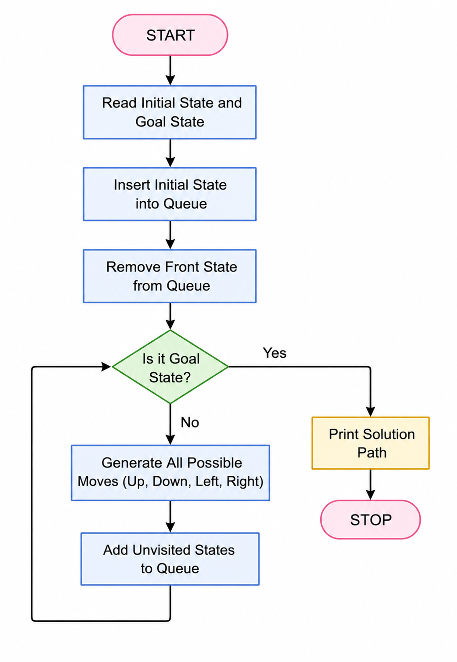

Source Code:

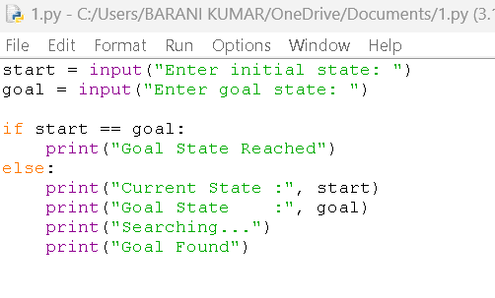

OUTPUT:
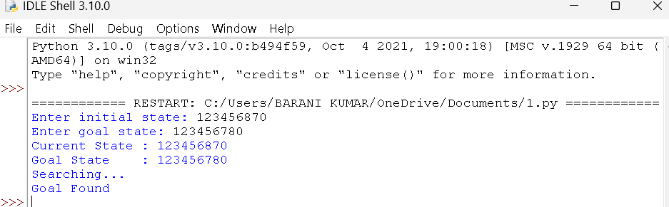

Result:
The 8-Puzzle Problem was successfully implemented, and the goal state was achieved by arranging the tiles in the correct order.

